**УО «Белорусский государственный университет информатики и радиоэлектроники»**

**Кафедра ПОИТ**

**Отчёт по лабораторной работе №1.3**

**По предмету**

**Основы алгоритмизации и программирования**

**Вариант 6**

**Выполнил:**

**Гладкий М.Г.**

**Проверила:**

**Данилова Г.В.**

**Группа 851001**

**Минск 2018**

**Задание:**

Даны два натуральных числа m и n (1<m<n). Найти наименьшее k, при котором mk>n.

**Код Delphi 10:**

**program** Project3;

{$APPTYPE CONSOLE}

**uses**

System.SysUtils;

**var**

Num10, Num1, Num2, Power : integer;

IsCorrect : boolean;

**begin**

writeln('This program looks for the smallest K for which M to the power K

greater than N');

writeln('Use natural numbers[2;2147483647], M should be greater than 1, N

should be greater than M');

IsCorrect := false;

**repeat**

**try**

readln(Num10,Num2);

**if** (Num10 > 1) **and** (Num2 > Num10) **then**

IsCorrect := true

**else**

writeln('You should use natural numbers[2;2147483647], M

should be greater than 1, N should be greater than M');

**except**

writeln('You should use natural numbers[2;2147483647], M should

be greater than 1, N should be greater than M');

**end**;

**until** IsCorrect;

Num1 := Num10;

Power := 1;

**while** Num1 < Num2 **do**

**begin**

inc(Power);

Num1 := Num1 * Num10;

**end**;

writeln('The smallest K for which M to the power K greater than N is:',

Power);

readln;

**end**.

**Код С:**

#include <stdio.h>

int main()

{

int Num10, Num2;

printf("This program looks for the smallest K for which M to the power K greater

than N\n");

printf("Use natural numbers[2;2147483647], M should be greater than 1, N should be

greater than M\n");

scanf_s("%d%d", &Num10, &Num2);

int Num1 = Num10;

int Power = 1;

if (Num10 > 1 && Num2 > Num10)

{

while (Num1 < Num2)

{

Power++;

Num1 *= Num10;

}

printf("The smallest K for which M to the power K greater than N is : %d",

Power);

}

else

printf("You should use natural numbers[2;2147483647], M should be greater

than 1, N should be greater than M\n");

return 0;

}

**Скриншоты:**

**Delphi 10:**

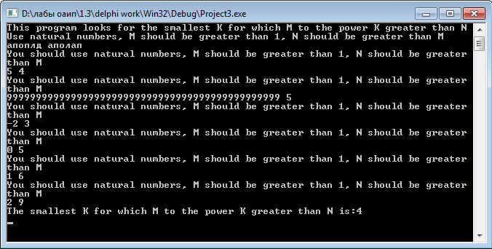

**C:**

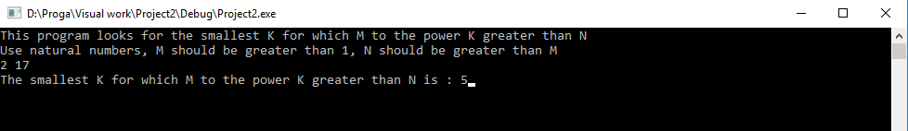

**Блок-схема:**

